Alex Yang

Professor Clark

CSE 3353

6 September 2018

Lab 1 Report

Raw Data:

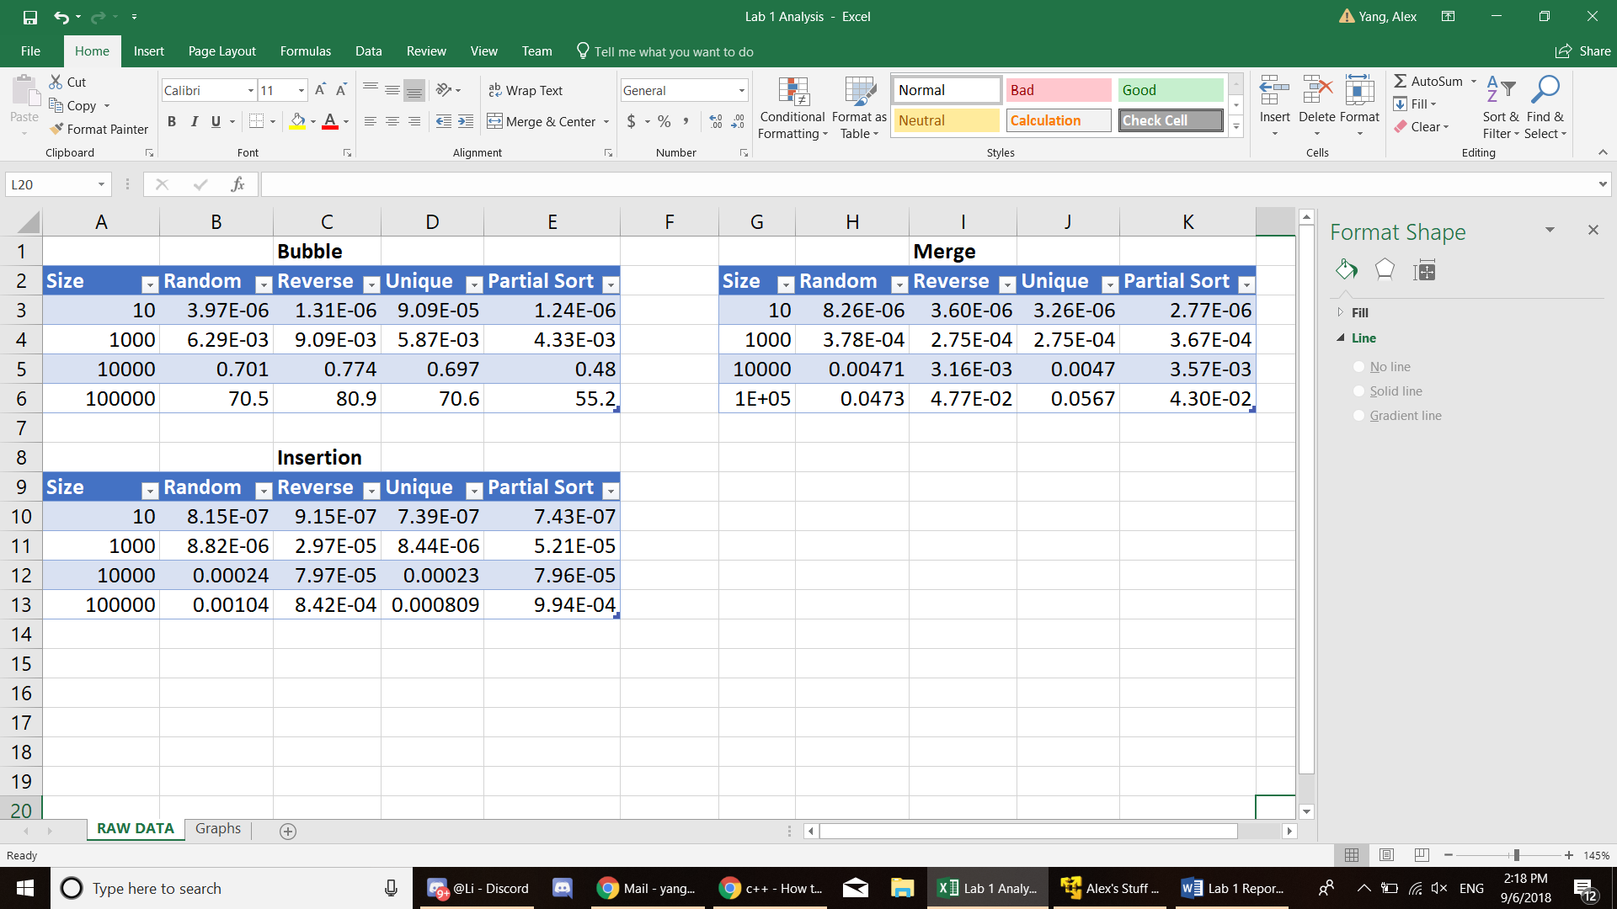

Graphs: